How to spot a fraudulent polymer banknote
The plastic notes are designed to be harder to counterfeit, although that hasn't stopped criminals from trying, please be aware of fraudulent notes when accepting cash. The most reliable method of identifying a counterfeit banknote is to compare it with a note of the same type which is known to be genuine.

All banknotes have the following security features which should be checked:
- The feel and raised print – polymer is a thin and flexible plastic material and on the front of the note, you can feel raised print in the bottom right hand corner
- The quality of the printing - printed lines and colours on the note are sharp, clear and free from smudges or blurred edges
- The hologram – Tilt the note from side to side. Check the words change between the value of the note and ‘Pounds’ (e.g. ‘Five’ and ‘Pounds)
- The metallic image over the window - The foil is gold on the front and silver on the back
- The silver foil patch - A silver foil patch contains a 3D image of the coronation crown. You will find this above the main see-through window on the front of the note
- The UV number - Under a good-quality ultraviolet light, the value appears in bright red and green on the front of the note

Spotting a fraudulent polymer £5 note
The best ways to check a Winston Churchill £5 banknote is genuine:
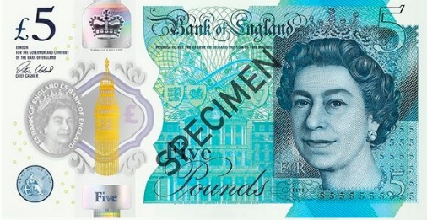
- Check the see-through window and a portrait of the Queen is printed on the window with ‘£5 Bank of England’ printed twice around the edge
- When you tilt the note, a coloured border around the edge of the see‑through window will change from purple to green
- Under a good-quality ultraviolet light, the number ‘5’ appears in bright red and green on the front of the note
- Check the circular green foil patch on the back contains the word ‘BLENHEIM’

Spotting a fraudulent polymer £10 note
As for the Jane Austen £10 banknote, look out for these features:
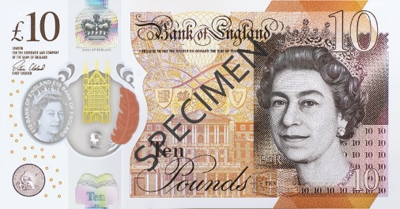
- There is a large see-through window on the note. At the side of this window, there should be a coloured quill that changes from purple to orange when you tilt the note
- On the front of the note, ensure you can feel raised print on the words ‘Bank of England’ and number 10 in the corner
- Under a good-quality ultraviolet light, the number ‘10’ appears in bright red and green on the front of the note
- Check the book-shaped copper foil patch on the back featuring the letters 'JA'

Spotting a fraudulent polymer £20 note
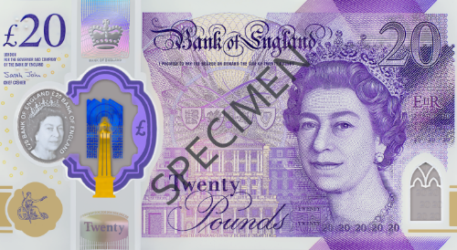
The JMW Turner £20 banknotes have these security features:
- Tilt the note from side to side. Check the words change between ‘Twenty’ and ‘Pounds’
- Look at the metallic image over the main window, check the foil is gold and blue on the front of the note and silver on the back
- There is an ultra-violet '20' which will appear in bright red and green on the front of the note
- Check the purple foil patch on the back, containing the letter 'T'

Still unsure? For further reference see Bank of England’s Guidelines here: BOE - Polymer Notes

Dealing with fraudulent notes
If fraudulent notes are identified, you must:
- Call the Branch Support Centre on 0333 345 5567 to obtain a reference number
- Place the note in a polythene banknote envelope and mark the envelope ‘Forged’ or ‘Counterfeit’
- Return the note and P6005 form in your next remittance to the cash centre
- Additionally, if the note is identified during a transaction it should be impounded and the customer issued with a receipt. If the customer is unable to provide a genuine replacement note the transaction should be amended accordingly
- Please also report any counterfeit notes to Grapevine on 0345 603 4004 so they can notify other branches in the area

More details on identifying and processing fraudulent / counterfeit banknotes can be found on Horizon Help:
- F7 Horizon Help
- F7 Retail
- F2 Methods of Payment
- F1 Cash Handling
- F4 Counterfeit Banknotes

